MATH 213 – Homework 14

- Exercise 8 from the chapter 12 exercises.

- A Gallup poll surveyed 3, 731 randomly sampled US residents in April 2021, asking how they felt about requiring proof of COVID-19 vaccination for travel by airplane. The poll found that 57% said they would favor it.

- The 57% is a statistic because it describes the sample. What is the corresponding parameter of interest, in words?
- Use StatKey to create a bootstrap distribution for this sample data. Copy and paste a picture of your bootstrap distribution here. Make sure to include the StatKey logo in your picture (and the buttons near it) so I can check to see if you have used the appropriate applet!
- Use your bootstrap distribution and the standard error from the graph to compute the 50% and the 95% confidence intervals. Be sure to tell me which is which.
- Write two sentences of interpretation – one for each confidence interval. “We are ___ confident that …”

- Use the formula calculate the standard error and make sure it’s close to the one in the graph above!

- In the National Health and Nutrition Examination Survey (NHANES), subjects were whether they had smoked at least 100 cigarettes in their lives. The researchers then asked the 2328 people who answered “yes” (our sample) the age at which they started smoking.

- Identify some features of this study. (I filled out part of this for you!)

Population of interest: US residents who have smoked at least 100 cigarettes

Variable of interest:

Type of variable (categorical or numerical):

What population parameter might we use the study data to estimate:

We can summarize the distribution of ages at which people in the sample started smoking with our usual tools: a frequency polygon and some summary statistics.
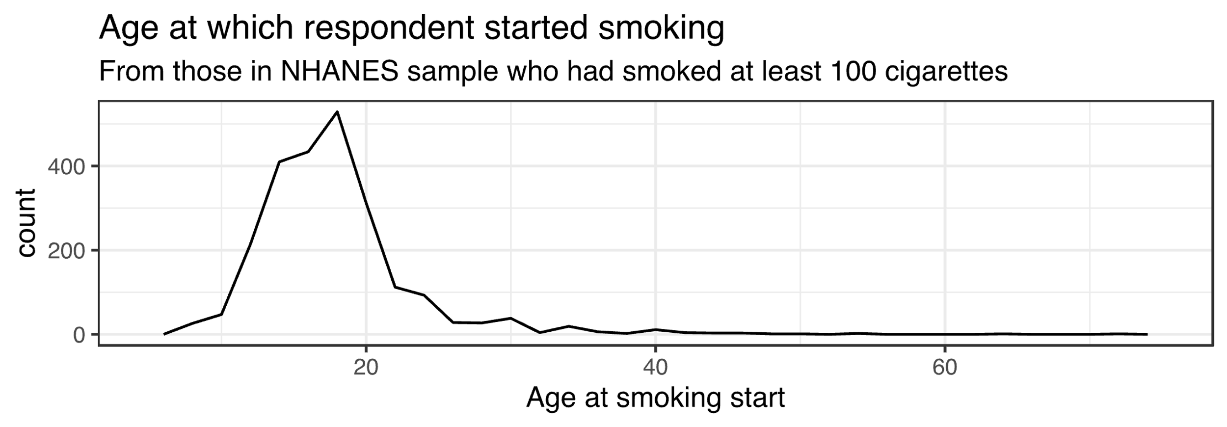
0.025 quantile | Q1 | median | Q3 | 0.975 quantile
11 years | 15 years | 18 years | 20 years | 31 years

mean | standard deviation
18.2 years | - years

- Describe the distribution of smoking-start ages in this sample of 2328 people who have smoked at least 100 cigarettes. As always, address the center, spread, and shape of the distribution. Include the context in your description.

- I have provided a CSV file containing the data from the study.
- Load this data file into the StatKey bootstrap applet “CI for Single Mean, Median, St. Dev” > Upload File as we have done in class.
- Use the applet to compute 50% and 95% bootstrap confidence intervals. Report them here.

- Write sentences of interpretation.
I am 95% confident that…

I am 50% confident that…

- Use the formula calculate the standard error and make sure it’s close to the one in the graph above!

